Name: Subject and Period:
Date: Neo-Confucian Ideas:
Neo-Confucian Ideas:
1) What did Confucius want to do before he became a teacher?
__________________________________________________________________________________________________________________
__________________________________________________________________________________________________________________
2) What was the name of the book that Confucius’ students wrote after his death?
__________________________________________________________________________________________________________________
__________________________________________________________________________________________________________________
3) What does the term Junzi mean?
__________________________________________________________________________________________________________________
__________________________________________________________________________________________________________________
Analysis: Compare and contrast the differences and similarities between Confucianism and Buddhism using a Venn diagram.

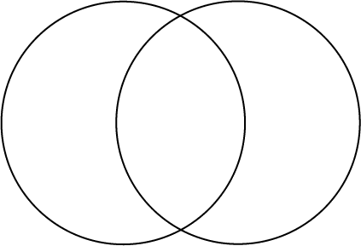
Connecting to the Past Questions:
4) How old were the Chinese boys / men when they took the Civil Service Exams? __________________________________________________________________________________________________________________
__________________________________________________________________________________________________________________
5) Why do you think taking the test was so stressful for these men? __________________________________________________________________________________________________________________
__________________________________________________________________________________________________________________
6) What was this new kind of Confucianism called? __________________________________________________________________________________________________________________
__________________________________________________________________________________________________________________
7) Why was this new form of Confucianism created by the Tang Dynasty?
__________________________________________________________________________________________________________________
__________________________________________________________________________________________________________________
8) What other two religions had an influence on this new form of Confucianism?
__________________________________________________________________________________________________________________
__________________________________________________________________________________________________________________
9) What is the merit system?
__________________________________________________________________________________________________________________
__________________________________________________________________________________________________________________
10) What types of people were able to take the civil service examinations?
__________________________________________________________________________________________________________________
__________________________________________________________________________________________________________________
11) What would students have to do in order to prepare for the exams?
__________________________________________________________________________________________________________________
__________________________________________________________________________________________________________________

Drawing Conclusions:
Complete the following question in a one paragraph open ended response.
Do you think China’s civil service system truly brought the most talented individuals into the government? How would you have made the system fairer?
__________________________________________________________________________________________________________________
__________________________________________________________________________________________________________________
__________________________________________________________________________________________________________________
__________________________________________________________________________________________________________________
__________________________________________________________________________________________________________________
__________________________________________________________________________________________________________________
__________________________________________________________________________________________________________________
__________________________________________________________________________________________________________________
__________________________________________________________________________________________________________________
__________________________________________________________________________________________________________________
__________________________________________________________________________________________________________________
__________________________________________________________________________________________________________________
__________________________________________________________________________________________________________________
__________________________________________________________________________________________________________________
__________________________________________________________________________________________________________________
__________________________________________________________________________________________________________________
__________________________________________________________________________________________________________________
__________________________________________________________________________________________________________________
__________________________________________________________________________________________________________________
__________________________________________________________________________________________________________________

